|  |  |  |  |
| --- | --- | --- | --- |
| **Übungsprotokoll**  **SYTB – Systemtechnik Betriebssysteme** | | | |
|  | **Übungsdatum:**  KW 35/2021 –  KW 38/2021 | **Klasse:**  3AHIT | **Name:**  Felix Schneider |
| **Abgabedatum:**  23.09.2021 | **Gruppe:**  SYTB_2 | **Note:** |
| **Leitung:**  DI (FH) Alexander MESTL | **Mitübende:**  - | | |
| **Übungsbezeichnung**:  Debian Server | | | |

**Inhaltsverzeichnis:**

1 Aufgabenstellung 3

1.1 Debian aufsetzen 3

1.2 Erweiterungspakete installieren 3

1.3 Knottenbelt Lecture III durcharbeiten 3

2 Theoretische Grundlagen 3

2.1 Debian aufsetzen 3

3 Übungsdurchführung 4

3.2 Erweiterungspakete installieren 4

3.3 Knottenbelt Exercise III durcharbeiten 4

3.3.1 Describe three different ways of setting the permissions on a file or directory to r--r--r--. Create a file and see if this works. 4

3.3.2 Team up with a partner. Copy /bin/sh to your home directory. Type "chmod +s sh". Check the permissions on sh in the directory listing. Now ask your partner to change into your home directory and run the program ./sh. Ask them to run the id command. What's happened? Your partner can type exit to return to their shell. 6

3.3.3 What would happen if the system administrator created a sh file in this way? Why is it sometimes necessary for a system administrator to use this feature using programs other than sh? 6

3.3.4 Delete sh from your home directory (or at least to do a chmod -s sh). 7

3.3.5 Modify the permissions on your home directory to make it completely private. Check that your partner can't access your directory. Now put the permissions back to how they were. 7

3.3.6 Type umask 000 and then create a file called world.txt containing the words "hello world". Look at the permissions on the file. What's happened? Now type umask 022 and create a file called world2.txt. When might this feature be useful? 7

3.3.7 Create a file called "hello.txt" in your home directory using the command cat -u > hello.txt. Ask your partner to change into your home directory and run tail -f hello.txt. Now type several lines into hello.txt. What appears on your partner's screen? 8

3.3.8 Use find to display the names of all files in the /home subdirectory tree. Can you do this without displaying errors for files you can't read? 9

3.3.9 Use find to display the names of all files in the system that are bigger than 1MB. 10

3.3.10 Use find and file to display all files in the /home subdirectory tree, as well as a guess at what sort of a file they are. Do this in two different ways. 10

3.3.11 Use grep to isolate the line in /etc/passwd that contains your login details. 11

3.3.12 Use find and grep and sort to display a sorted list of all files in the /home subdirectory tree that contain the word hello somewhere inside them. 11

3.3.13 Use locate to find all filenames that contain the word emacs. Can you combine this with grep to avoid displaying all filenames containing the word lib? 11

3.3.14 Create a file containing some lines that you think would match the regular expression: (^[0-9]{1,5}[a-zA-Z]+$)|none and some lines that you think would not match. Use egrep to see if your intuition is correct. 12

3.3.15 Archive the contents of your home directory (including any subdirectories) using tar and cpio. Compress the tar archive with compress, and the cpio archive with gzip. Now extract their contents. 12

3.3.16 On Linux systems, the file /dev/urandom is a constantly generated random stream of characters. Can you use this file with od to printout a random decimal number? 14

3.3.17 Type mount (with no parameters) and try to interpret the output. 15

4 Ergebnisse 15

5 Kommentar 15

# Aufgabenstellung

## Debian aufsetzen

## Erweiterungspakete installieren

## Knottenbelt Lecture III durcharbeiten

# Theoretische Grundlagen

## Debian aufsetzen

Wichtige Fakten:

* Debian Version: 11
* RAM 4GB
* Festplattenspeicher: 16GB (dynamisch)
* deutsche Tastatur
* 200MB SWAP

# Übungsdurchführung

## Erweiterungspakete installieren

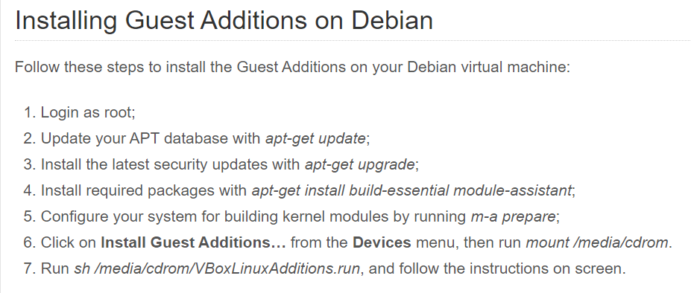

Apt-get-update / -upgrade ist nicht notwendig, wenn man die virtuelle Maschine gerade installiert hat…

Bei Ausführung des 4. Schrittes werden wichtige Pakete heruntergeladen.

m-a prepare sorgt dafür, dass der Kernel veränderbar ist.

## Knottenbelt Exercise III durcharbeiten

### Describe three different ways of setting the permissions on a file or directory to r--r--r--. Create a file and see if this works.

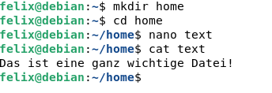

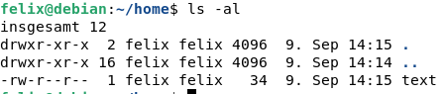

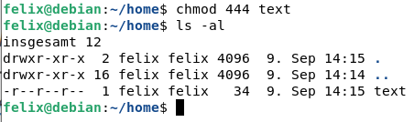

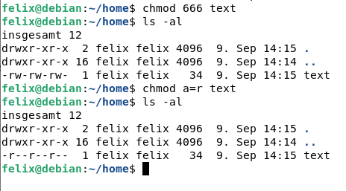

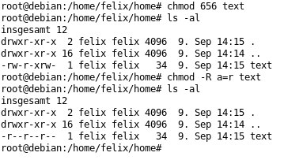

### Team up with a partner. Copy /bin/sh to your home directory. Type "chmod +s sh". Check the permissions on sh in the directory listing. Now ask your partner to change into your home directory and run the program ./sh. Ask them to run the id command. What's happened? Your partner can type exit to return to their shell.

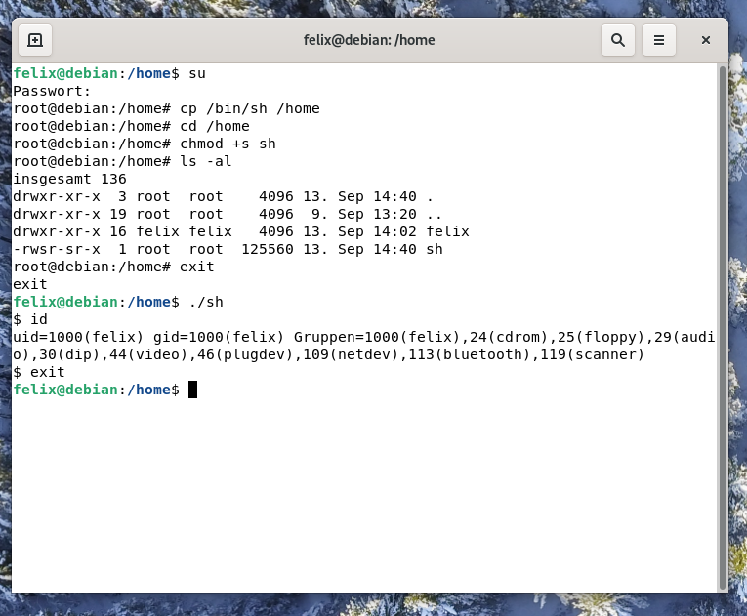

### What would happen if the system administrator created a sh file in this way? Why is it sometimes necessary for a system administrator to use this feature using programs other than sh?

Würde ein Administrator die sh-Datei mittels dieser Methode erstellen, so könnte andere Benutzer die Date zwar ausführen, diese allerdings nicht verändern.

Dies muss der Administrator zum Beispiel machen, wenn er allen Benutzern ein Verzeichnis zur Verfügung stellt, das ausführbare Dateien enthalten soll, die allerdings nicht veränderbar sein sollen. Zum Beispiel Druckerkonfigurationen oder Netzwerkkonfigurationen. Der Vorteil dieses „sticky“-Bits ist, dass der Administrator persönlich die Datei zwar verändern kann, alle anderen Benutzer jedoch nicht.

### Delete sh from your home directory (or at least to do a chmod -s sh).

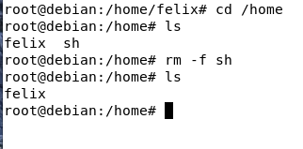

### Modify the permissions on your home directory to make it completely private. Check that your partner can't access your directory. Now put the permissions back to how they were.











### Type umask 000 and then create a file called world.txt containing the words "hello world". Look at the permissions on the file. What's happened? Now type umask 022 and create a file called world2.txt. When might this feature be useful?

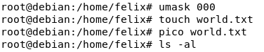

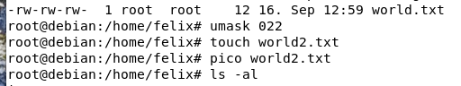



Mithilfe von umask kann man im Vorhinein schon festlegen, welche Berechtigungen die folgenden Dateien haben sollen.

### Create a file called "hello.txt" in your home directory using the command cat -u > hello.txt. Ask your partner to change into your home directory and run tail -f hello.txt. Now type several lines into hello.txt. What appears on your partner's screen?

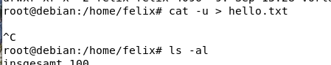

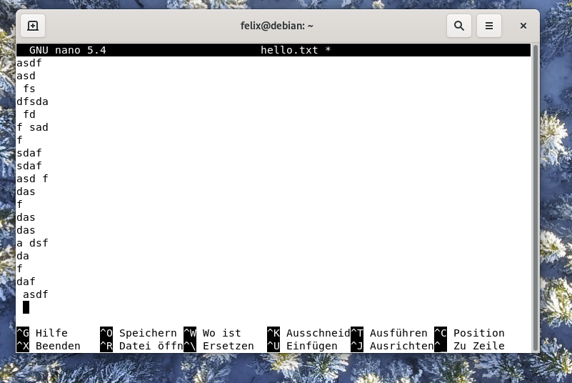

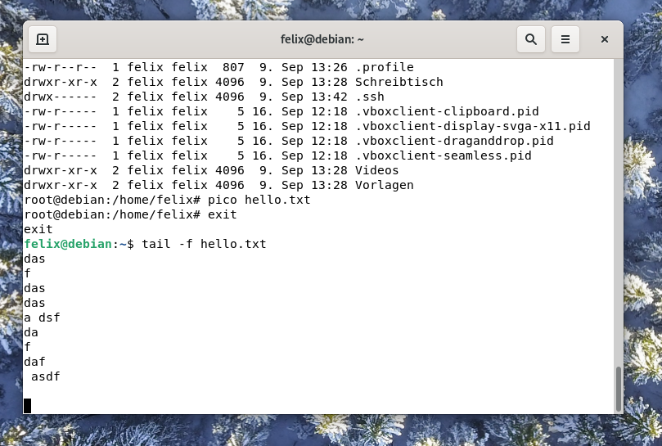

Der Partner sieht immer den „Footer“ der Datei.

### Use find to display the names of all files in the /home subdirectory tree. Can you do this without displaying errors for files you can't read?



### Use find to display the names of all files in the system that are bigger than 1MB.

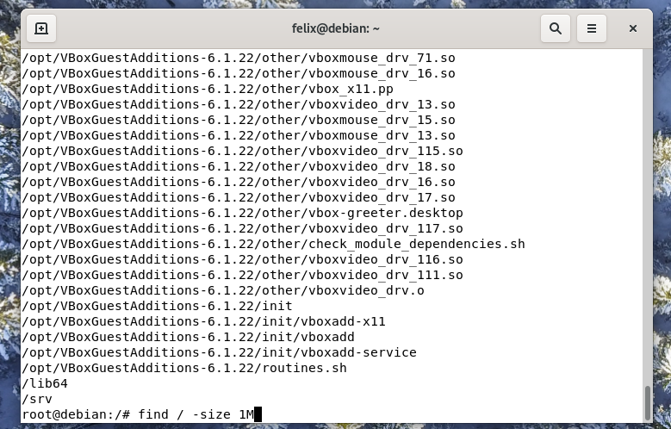

### Use find and file to display all files in the /home subdirectory tree, as well as a guess at what sort of a file they are. Do this in two different ways.

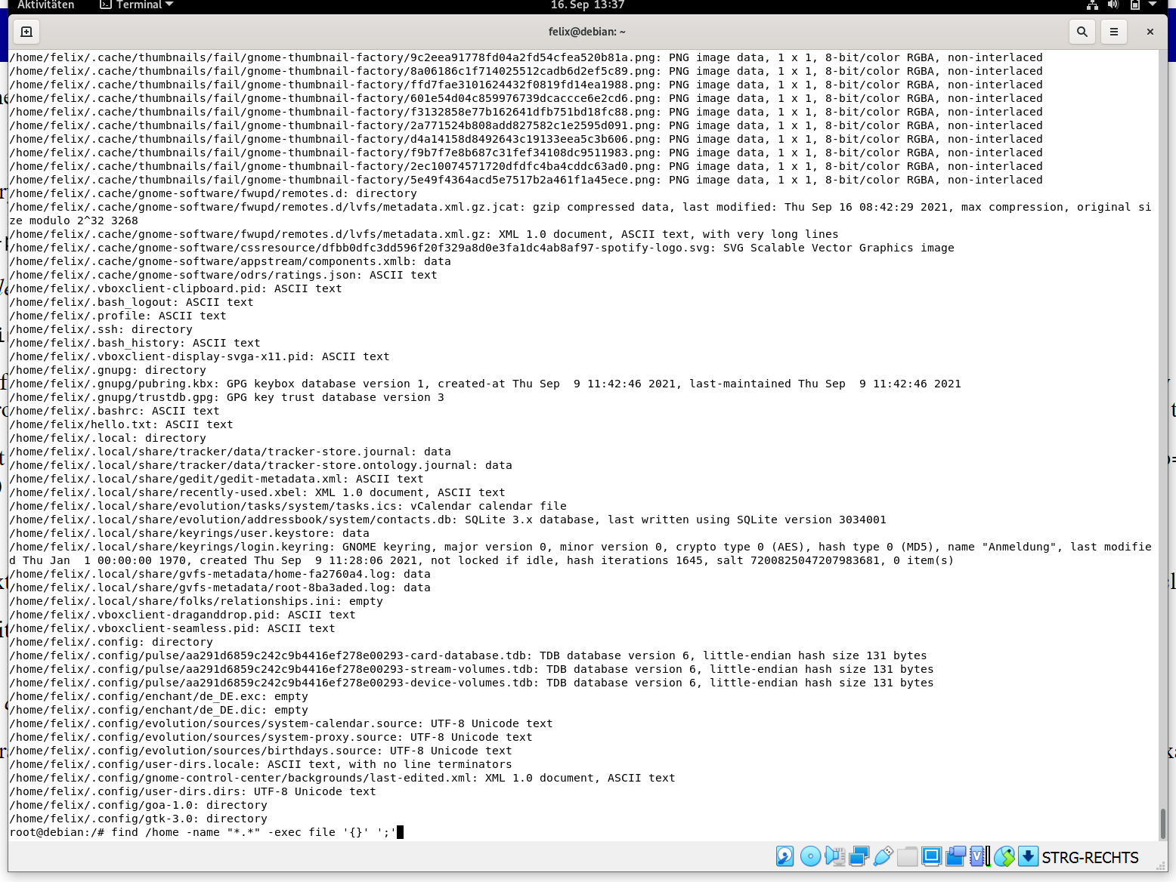



### Use grep to isolate the line in /etc/passwd that contains your login details.

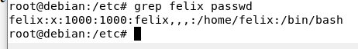

### Use find and grep and sort to display a sorted list of all files in the /home subdirectory tree that contain the word hello somewhere inside them.

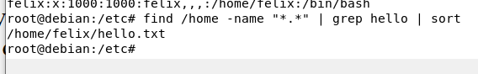

### Use locate to find all filenames that contain the word emacs. Can you combine this with grep to avoid displaying all filenames containing the word lib?

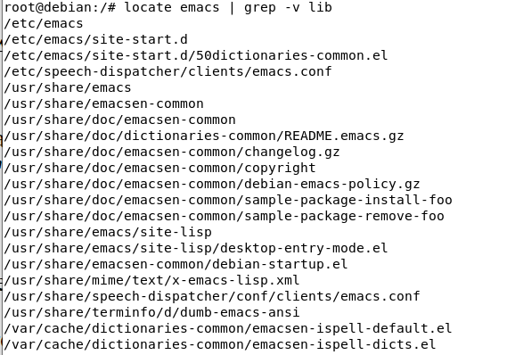

### Create a file containing some lines that you think would match the regular expression: (^[0-9]{1,5}[a-zA-Z]+$)|none and some lines that you think would not match. Use egrep to see if your intuition is correct.

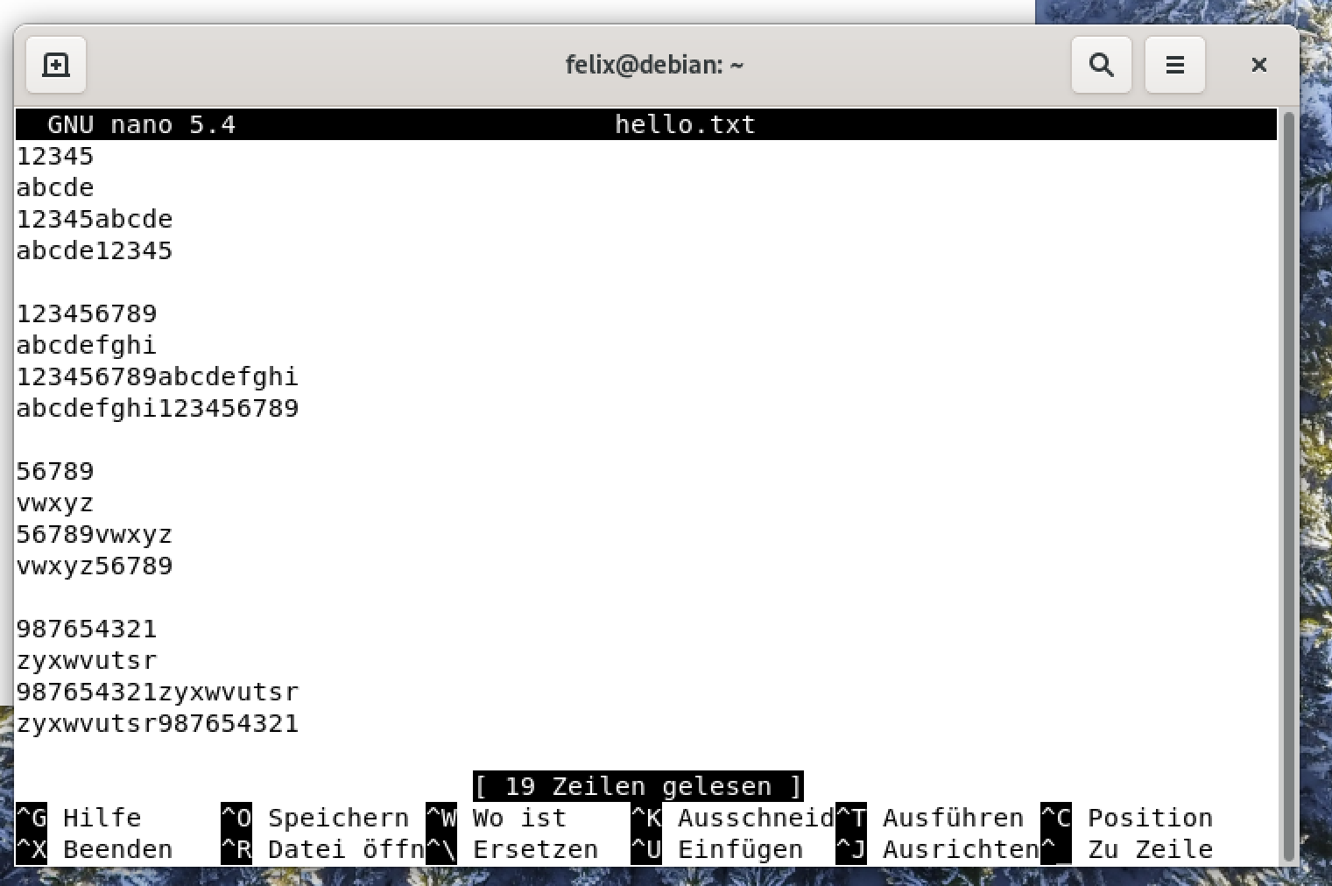



Es dürfen bis zu 5 Zahlen am Anfang der Zeile stehen, gefolgt von beliebigen Buchstaben.

### Archive the contents of your home directory (including any subdirectories) using tar and cpio. Compress the tar archive with compress, and the cpio archive with gzip. Now extract their contents.

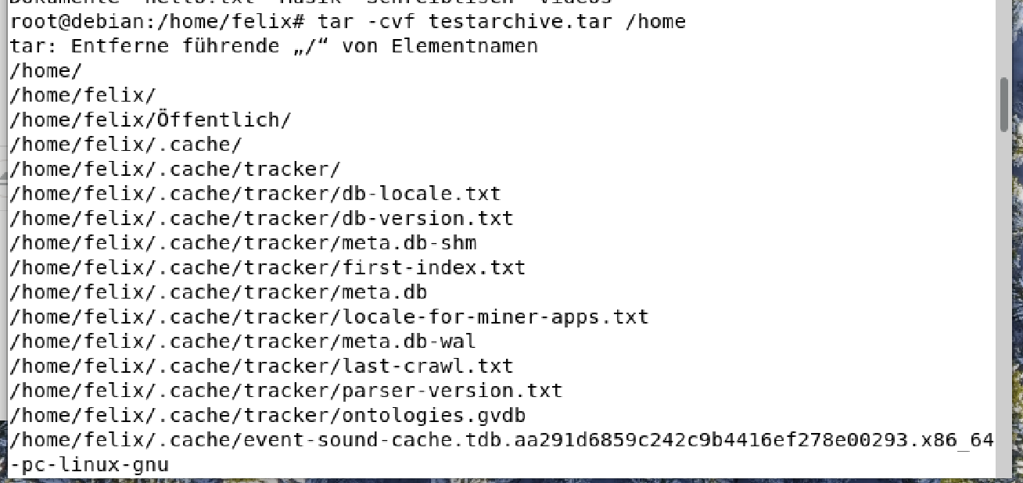

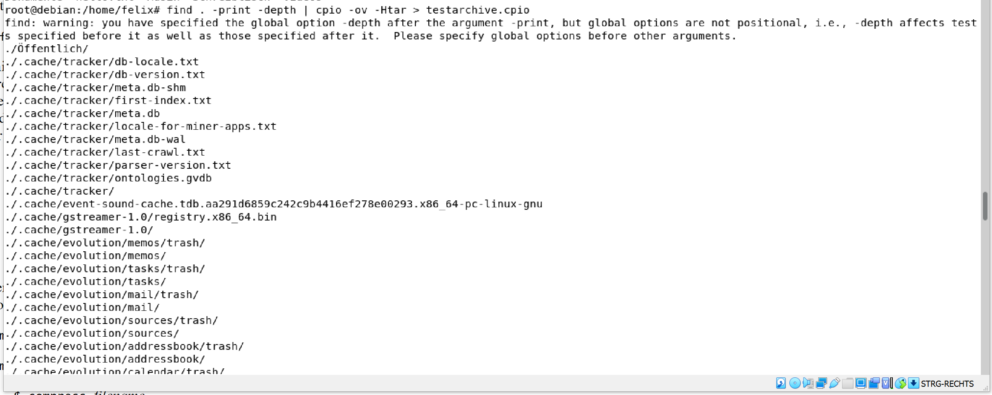

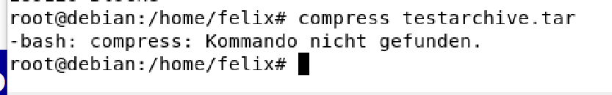

Das zusätzliche compress-Paket wollen wir nicht installieren, weil die Suche danach zu aufwendig ist und wir zu faul dafür sind ☺. Die komprimierte tar Datei hätte als Endung ein großes Z, bei cpio ist die Endung gz:

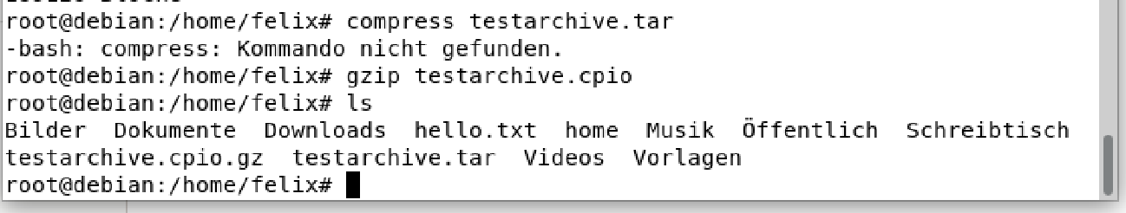

### On Linux systems, the file /dev/urandom is a constantly generated random stream of characters. Can you use this file with od to printout a random decimal number?

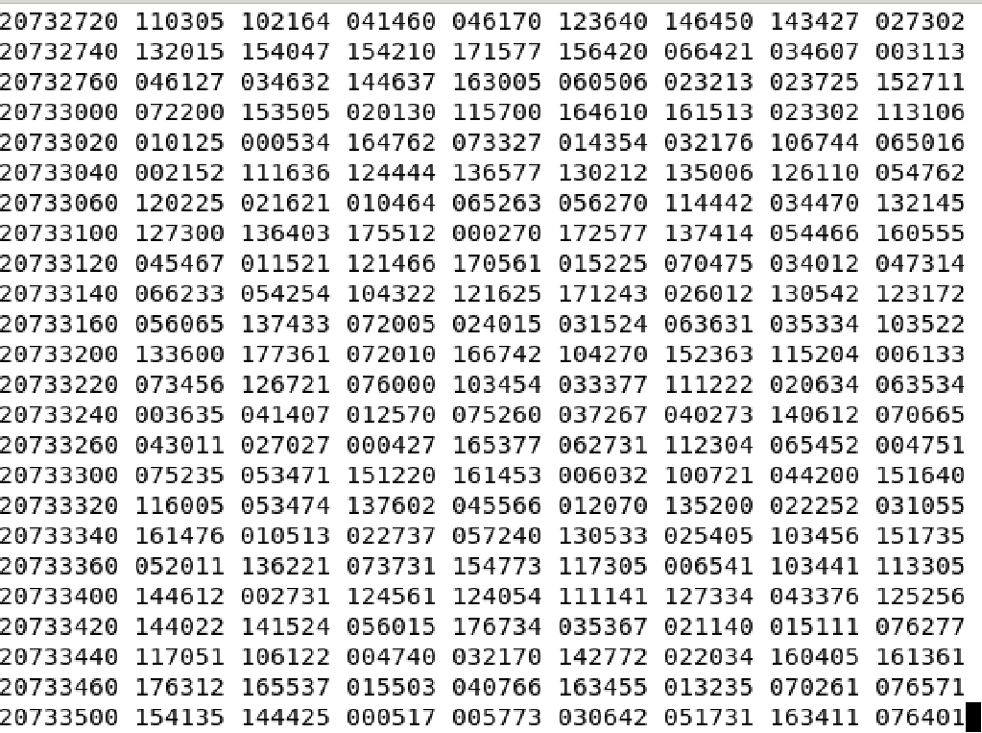

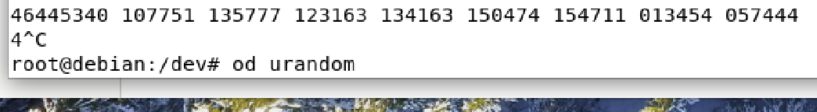

### Type mount (with no parameters) and try to interpret the output.

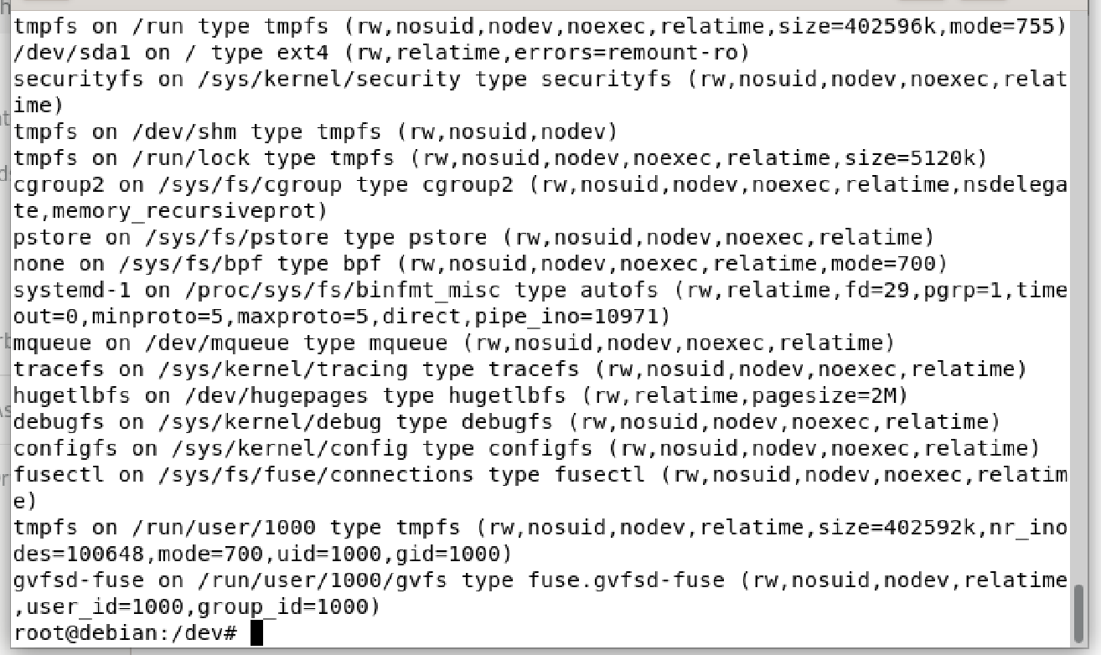

Ich interpretiere, dass das die eingehängten Datenträger zeilenweise ausgegeben werden.

# Ergebnisse

Debian aufgesetzt

# Kommentar

Die Interpretation ist natürlich von mir selbst.